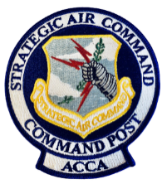
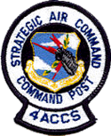
2025 4ACCS & SAC ACCA Combined Reunion
June 25 – 29, 2025
Courtyard by Marriott Bellevue
at Beardmore Event Center
3730 Raynor Parkway
Bellevue, NE 68123
This year’s combined 4ACCS and SAC Airborne Command Control Association (ACCA) Reunion will be in
the Omaha, Bellevue, Offutt AFB, Ashland Nebraska area. Registration will start on Wednesday and continue Thursday with SAC ACCA conducting their business meeting on Thursday morning, followed by a tour of the
SAC Museum, and then return to the hotel for a joint reception in the evening.
On Friday we will be offering USSTRATCOM briefings and tours, visit with the 625 STOS and their
heritage room and airborne procedures trainer (APT) along with the possibility of a tour of an E-6B Mercury
aircraft depending on availability. Our joint banquet will be held on Friday evening at the Offutt AFB Event
Center. (War Hawk)
On Saturday, 4 ACCS will be conducting a Memorial Bench Dedication at EC-135A AC#0287, which is on
static display at Offutt AFB, to honor those who served at 4 ACCS and have “gone west”!
Then finally, everyone will have the opportunity to take a self-guided walking tour in Omaha featuring the
History of the Old Market and the surrounding neighborhood with free time for shopping, sightseeing and lunch
at Billy Frogg’s Bar and Grill or restaurant of your choice.
* * * * * Transportation fee included in all tours * * * * *
A block of rooms has been set aside at the Courtyard by Marriott Bellevue as addressed above. For hotel reservations call (402) 408-5300 or book a room on-line at: https://bit.ly/4ACCS. Room block rates cannot
be guaranteed after Monday, May 25, 2025. For more lodging go on-line to: https://www.gosarpy.com, or
for campsites /cabins at Eugene T Mahoney State Park go to: https://outdoornebraska.gov/ Looking forward
to seeing everyone at this year’s reunion!
Omaha Fun/City Walks – you will be on your own to shop and walk through the streets of Omaha. There
is also the self-guided Walking Tour of the History of the Old Market nearby the bus drop off and picking up
area. The OLD MARKET is Omaha’s most historic, most entertaining neighborhood. The cobblestone streets
are home to a diverse mix of shopping, galleries, restaurants, and more. Check out their website at: https://oldmarket.com/old-market-history.
4ACCS Reunion
c/o Mary Hillman Telephone (320) 760-8235
68393 430th Street website: www.4accs.com
Odessa, MN 56276 email: 4accs.contact@gmail.com
SCHEDULE of EVENTS
WEDNESDAY – June 25 1600 – 1800 Early Registration (Salon G)
Dinner on own (hotel bistro available 5pm – 10pm)
THURSDAY – June 26 0630 – 0900 Breakfast on own (hotel bistro available 6:30am – 10am)
0900 – 1100 SAC ACCA Business Meeting (Salon B & C)
1100 – 1215 Lunch on own
1215 Board bus for SAC Museum
1230 Bus departs
1300 Arrive at Museum
1300 – 1400 Tour AC #049
1400 – 1645 Tour Museum on your own
1645 Board bus back to hotel
1700 Bus departs
1730 Arrive at hotel
1800 – 2200 4ACCS & SAC ACCA Welcome Reception (Salon B & C)
Registration cont’d w/ Cash Bar and Hors D'oeuvre
FRIDAY – June 27 0630 – 0800 Breakfast on own (hotel bistro available 6:30am – 10am)
0815 Board bus to Offutt AFB (Military ID or Driver’s License)
0830 Bus departs hotel to Offutt AFB
0900 Arrive at Offutt AFB Visitors Center
0900 - 0930 USSTRATCOM Security Processing
0930 – 1200 USSTRATCOM Tours and Briefing
1200 - 1300 Chick-fil-a Lunch provided for those on tour
1300 – 1530 Old SAC Headquarters/625 STOS/ALCS Heritage Room/APT
1530 Bus departs back to hotel (E-6B tour if available)
1600 Arrive at hotel
1730 Board bus to Offutt AFB for banquet (Military ID/Driver’s License)
1745 Bus departs hotel
1815 Arrive at Offutt Visitors Center (ID check)
1845 – 2000 Social Hour – Offutt AFB Event Center (War Hawk)
2000 BANQUET Begins – Opening Remarks
-Buffet Dinner
-Formal Program
-Guest Speaker - Lt Col Richard Hodges, USAF, Retired
2200 Board bus to hotel
2215 Bus departs
2245 Arrive back at hotel
SATURDAY – June 28 0630 - 0800 Breakfast on own (hotel bistro available 6:30am – 10am)
0815 Board bus to Offutt AFB (Military ID or Driver’s License)
0830 Bus departs
0900 Arrive at Offutt AFB Visitor Center
0930 - 1030 4ACCS AC#287 Memorial Bench Dedication Ceremony
1030 Bus departs for Omaha FUN/City Walks
1200 Lunch on own -or- meet at Billy Frogg’s Bar and Grill
1500 First bus departs back to hotel
1600 Second bus departs back to hotel
Dinner on own (hotel bistro available 5pm – 10pm)

SUNDAY – June 29 0630 - 1000 Breakfast on own (hotel bistro available 6:30am – 10am)
4ACCS & SAC ACCA assumes no liability for accidents, injuries or death of attendees at the Reunion!
______________________________________________________________________________________________________________________________________________________________________________________________________________________________________________________________________________________________________________________________________________________________________________________________________________________________________________________________________________________________________________________________________________________________
REGISTRATION
(Fill out and return to address below with payment or register on line. – deadline May 12, 2025. Registration’s post marked after May 13th and please add $10 per person, late fee. A non-refundable charge of $30 per person applies for cancellations. No refunds after May 12.
NAME: _________________________________________ Spouse: __________________________________

Address: _________________________________________________________
_________________________________________________________

Email: ___________________________________________________________________________________

Cell Phone: ________________________ Years/Squadron/Branch ___________________________________
(i.e.: yyyy-yyyy/4ACCS/ALCS)
Base Tour ID Required:
Complete the Base Tour ID Form (page 4) and submit with registration. Photo ID required on base!

REGISTRATION FEE $30 per person = ___________
(Indicate number attending)
THURSDAY
______ SAC ACCA Business Meeting
______ SAC Museum Tour (transportation & entrance fee included) $56 per person = ___________
______ AC#049 Tour

______ SAC ACCA & 4ACCS Welcome Reception $50 per person = ___________

FRIDAY (cost includes all day transportation)
______ Offutt AFB Bus Tours $60 per person = ___________
USSTRATCOM Tours and briefing, Old SAC Headquarters,
Headquarters, 625 STOS ALCS Heritage Room/APT (TBD – E-6B Tour)
______ Chick-Fil-A Sack Lunch $14 per person= __________
______ Banquet – Offutt Event Center
Buffet – Chicken or Roast Beef, Potato, Veg, Salad & Dessert $76 single / $146/couple = __________
SATURDAY
AC#287 Memorial Bench Dedication/Folded Wings Ceremony (Offutt AFB)
______ & Omaha Bus Tour (departs from Offutt AFB) $46 per person = ___________
-or-
______ Omaha FUN/City Walks Tour Only (departs from hotel) $46 per person = ___________
______ Billy Frogg’s Bar and Grill (head count needed)
SUNDAY
_______ Breakfast on own (hotel bistro available)

____ On-line Registration w/ CC payment -or- Enclosed Check in amount of $________
Make check payable to your organization listed below. Send/email completed form and payment to:
4ACCS Reunion Telephone (320) 760-8235
c/o Mary Hillman website: www.4acc.com
68393 430th Street email: 4accs.contact@gmail.com
Odessa, MN 56276
Complete the Base Tour ID Form below and submit with registration. Photo ID required at tour!
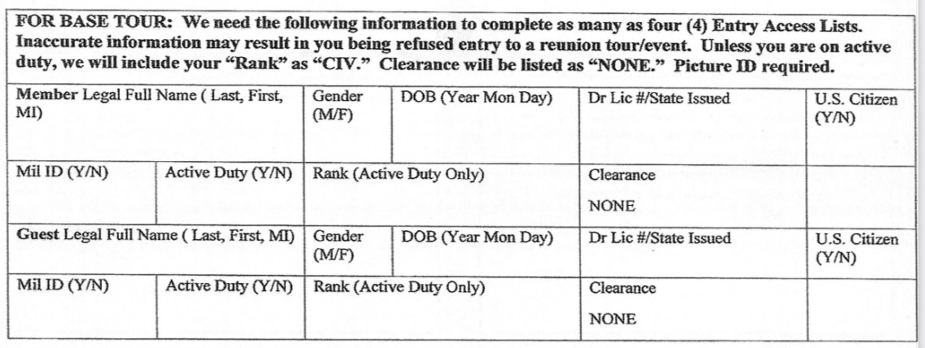
Reunion Memorabilia
There will be past merchandise and 2025 Reunion T-Shirts available. Please list size and quantity ordering below. If paying by check include payment on registration page. On-line registrations will have a place to order T-Shirt. If you are ordering by mail add $12 for shipping and handling.
2025 REUNION T-Shirts
MEN’S S,M, L, XL = $24 each WOMEN’S
____ Small ____ Small
____ Medium ____ Medium
____ Large ____ Large
____ X-Large ____ X-Large
XX-Large to XXXX-Large = $26 each
____ XX-Large ____ XX-Large
____ XXX-Large ____ XXX-Large
____ XXXX-Large ____ XXXX-Large

